SCHOOL OF ELECTRICAL ENGINEERING AND COMPUTER SCIENCE

COURSE: SEG2106 | PROFESSOR: Gregor v. Bochmann
SEMESTER: WINTER 2016 | DATE: March 1, 2016
 | TIME: 14:30 to 16:00

MIDTERM EXAMINATION

Solutions (revised March 12)

Name and Student Number: / _

Mid-Term Exam

There are three (3) types of questions in this examination.
Part 1 | Short answer questions | 23 marks
Part 2 | Development questions | 27 marks
Part 3 | Problem solving | 15 marks
Total |  | 65 marks

The space allocated for each question is limited. In case of necessity you may use the other side of the pages to continue.

Note: There is limited time. Do not spend too much time on the questions that give only two or three points.

Annex A: Example of LTSA model specification and tool output

Annex B: Algebraic Equivalence Properties of Regular Expressions

Short-answer questions:
- [4 marks] The sequence diagram below shows an execution scenario where component A executes two sending and two receiving events, and component B executes three receiving events and one sending event. We assume that incoming messages are stored in a FIFO input queue.

Question (a): (2 points) Write down the state machine models of A and B (showing the states and input and output interactions) which correspond to the execution scenario given by the sequence diagram.

Question (b): (2 points) Could the concurrent execution of the two state machines of point (a) give rise to an execution scenario different than the one shown by the sequence diagram on the left, and possibly involving a situation of non-specified reception ? – If yes, draw an example of such a sequence diagram, if no, explain why not.

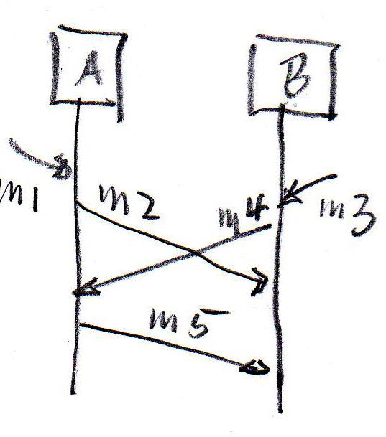 | Answer (a):  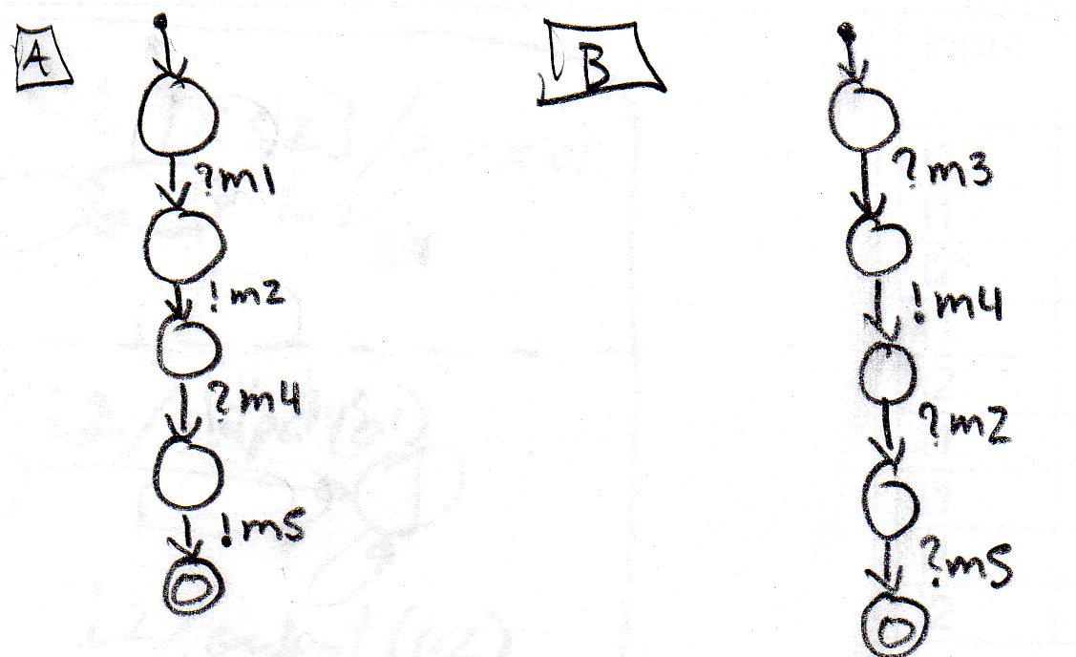

Answer (b):

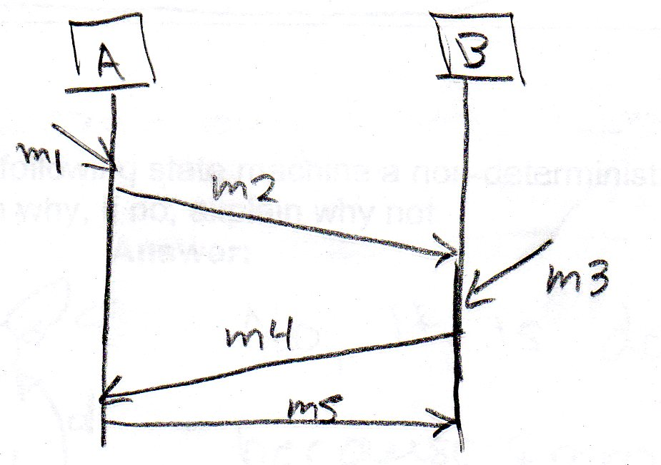 or 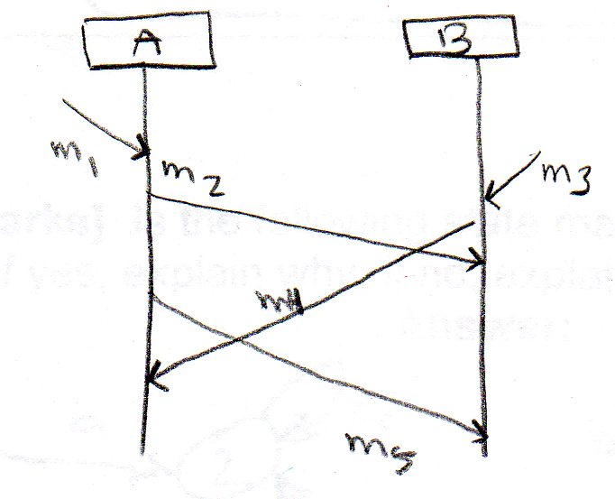

- [2 marks] Does the following regular expression define the same language as the accepting automaton shown here ?

- regular expression: (a | b c a )* b (ϵ | c)

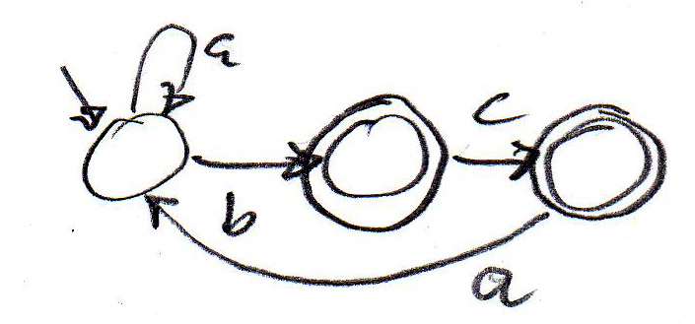

Answer: (a) YES (b) NO

Note: (a | b c a )* corresponds to the two loops from the initial state, b (ϵ | c) goes to the second or third state (which are accepting).

- [2 marks] Do the following two regular expressions define the same language ? (see also Annex B)

( a b a | c )* (a b | b)

( ( a b a)* c* )* ( ϵ |a ) b

Answer: (a) YES (b) NO

Note: ( a b a | c )* and ( ( a b a)* c* )* are equivalent (Annex B), what follows is also equivalent in the two expressions.

- [3 marks] The diagram below shows a UML State Diagram, where i1 and i2 are inputs, and x is an integer variable.

Complete the table on the right side. The first column of the table contains the sequence of inputs that are applied to the state machine. The second column contains the value of the variable x at the end of the transition triggered by the input, and the third column contains the output produced by the transition (if any).

Answer:
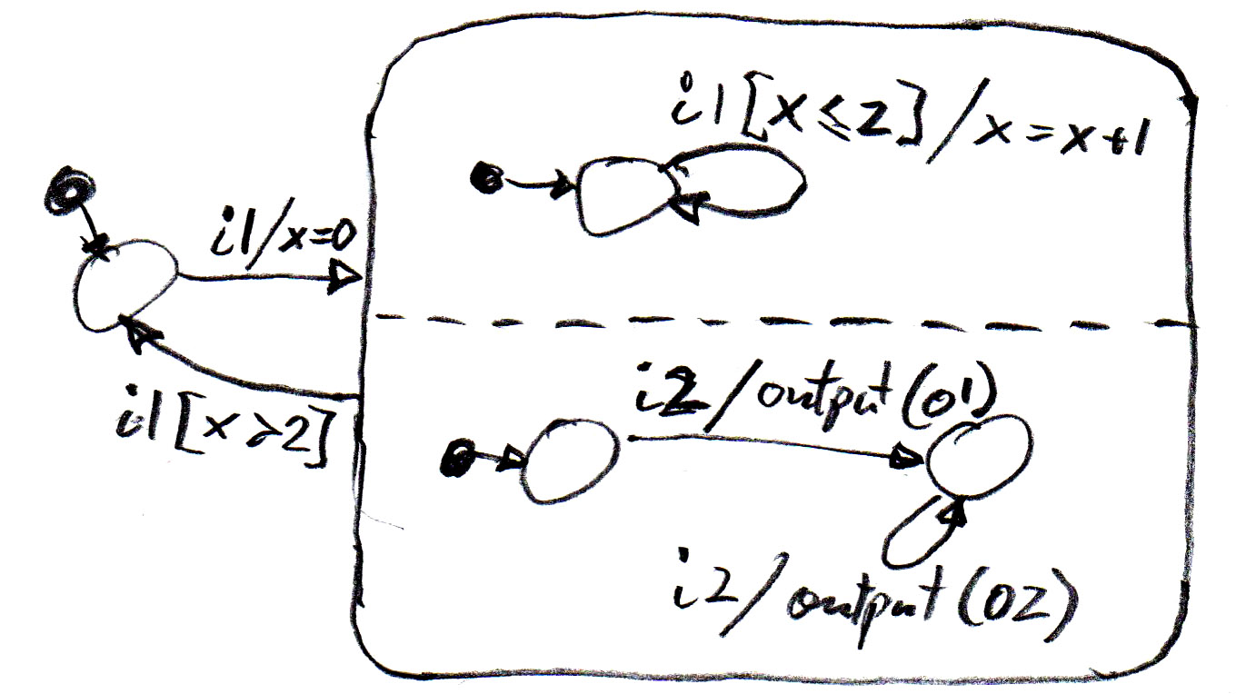
  input | Value of x | output
  i1 | 0
  i1 | 1
  i2 | 1 | O1
  i1 | 2
  i2 | 2 | O2
  i1 | 3
  i1 | 3
  i1 | 0
  i2 | 0 | O1

Note: the inner part of the hierarchical state represents two concurrent state machines.

- [2 marks] Is the following state machine a non-deterministic state machine ?

If yes, explain why, if no, explain why not.

Answer: NO, this machine has no e-transition, and there is no state with two transitions with the same input going to two different next states.

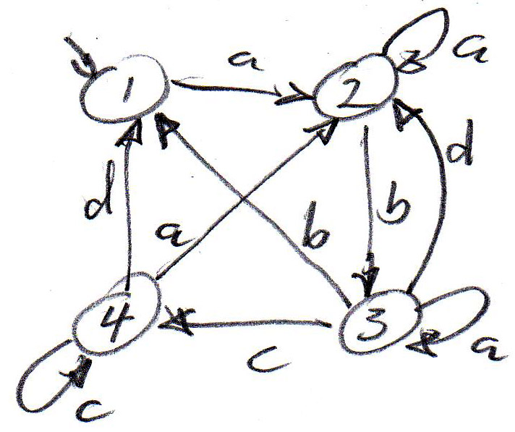

- [5 marks] Below is an extract from a file destined as input to the LEX (or Flex) tool.

Extract from LEX input file:
NUMBER [0-9]+
IDENT [a-z0-9]* [;|:]
%%
{NUMBER} {printf("yyy\n", yytext); }
{IDENT} { ++identifiers; }
“!=“{NUMBER} {printf("xxx\n", yytext); }

Question (a): (2 points) Explain in a few words, what is the meaning of the second line.

This line defines the regular expression IDENT to represent any number (0, 1 or more) of lower-case letters or digits followed by a semi-colon or a colon.

Question (b): (1 point) Explain in a few words, what is the meaning of the second line after %% .

When a string represented by IDENT is found, the variable “identifier” will be incremented.

Question (c): (2 points) Explain in a few words, under what conditions “xxx” will be printed.

“xxx” will be printed when the program finds the “!” character followed by the “=” character followed by one or more digits.

- [5 marks] Annex A contains a modified specification the hotel example seen in the class (Lab-2) in the format of the LTSA tool. The specification contains a little problem. The annex also contains the output produced by the tool when the command “CHECK” -- “safety” was executed.

Question (a): (2 points) Explain in a few words the meaning of the output produced by the tool.

The output produced by the LTSA tool is informing the user that the current system does not satisfy the property check_A. The output of the tool shows a sequence of interactions that can be executed and that leads to the property violation.

Question (b): (3 points) Explain in a few words the nature of the problem in the specification. Can you suggest a simple modification to one of the system components in order to solve the indicated problem ?

The property check_A states that the interaction payCash must follow an eat interaction before another eat interaction occurs. This is not satisfied by the interaction sequence shown by the tool. This problem can be solved by replacing in the definition of CLIENT, the interaction chargeRoom after eat by the interaction payCash.

Development questions

- [3 marks] Write down a regular expression that defines the regular language accepted by the following automaton:

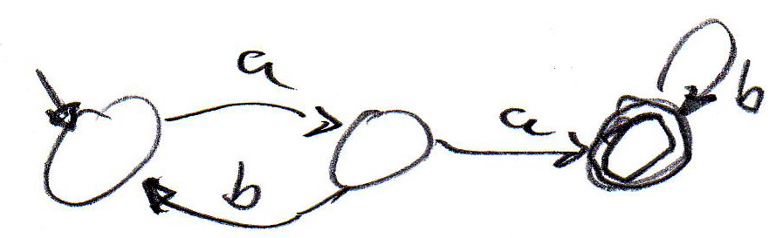 Answer: a ( b a )* a b*

or ( a b )* a a b*

- [3 marks] Please draw a state diagram of an accepting automaton that accepts exactly the language defined by the regular expression b* ( a b )*

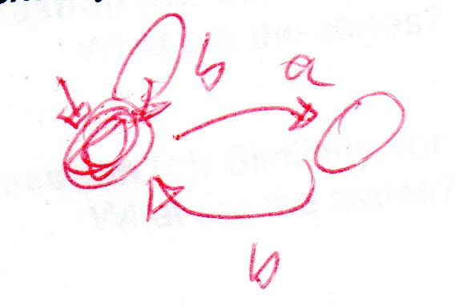 This was my first solution. But it is wrong. It corresponds to the regular expression ( b | ab )*. The following is a good solution – the initial and the third state are accepting.

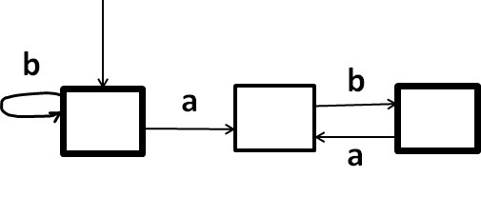

Note: Adjustment of marks – all students will get 3 marks for this question, irrespective of their answer.

- [5 marks] Write down a regular expression that defines the sequences of characters that represent an assignment statement in Java. You may assume that the left side is an identifier representing an integer variable and the right side is either an integer number of the call of a method which may have zero, one or more integer parameters – the effective parameters are simple integer values.

You may assume that the following definitions are given:

id = alpha (alpha | digit)* -- definition for identifiers

num = digit+ -- definition of an integer

Answer:

Id “=” ( num | id “(“ ( epsilon | num ( “,“ num )* ) “)“ ) “;“

or: id id “=” … etc.

[4 marks] We consider the following non-deterministic accepting automaton.

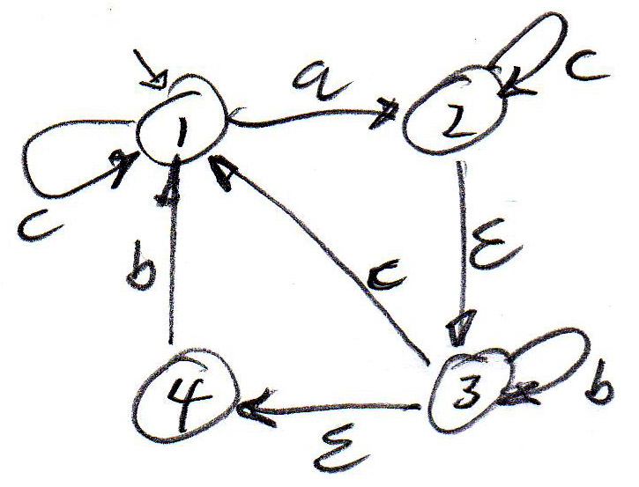 Note: state 2 is accepting

Question (a): What are the states in which the automaton could be after having read the input sequence “ a b “ ?

Answer: 3, 1, 4

Would this input string be accepted ? - YES NO

Question (b): Similarly, for the input sequence “ a c “ ?

What are the states? … 1, 2, 3, 4 Is it accepted ? YES NO

Question (c): Similarly, for the input sequence “ a c c “ :

What are the states? … 1, 2, 3, 4 Is it accepted ? YES NO
- [6 marks] The diagram below shows an architecture diagram with two state machines A and B that communicate with one another by exchanging the messages m1, m2 an m3. They also exchange messages with the environment, as indicated by the architecture diagram. In addition, the figure below shows the dynamic behavior of the two state machines. Both have the same behavior.

Architecture diagram Behavior diagram

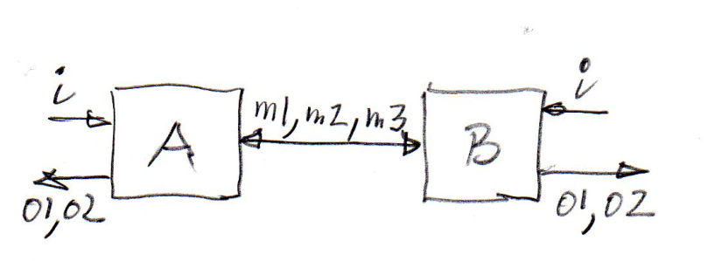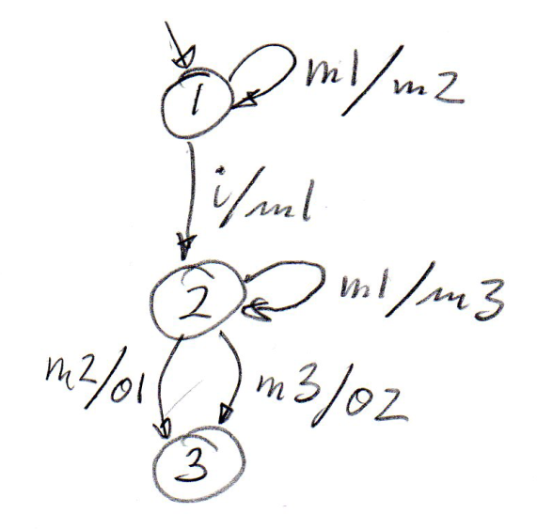

Question (a): (3 points) Write down a sequence diagram showing the actors in the environment of the two machines and the two state machines, as well as the messages exchanged for the following scenario: A receives an i input from the environment.

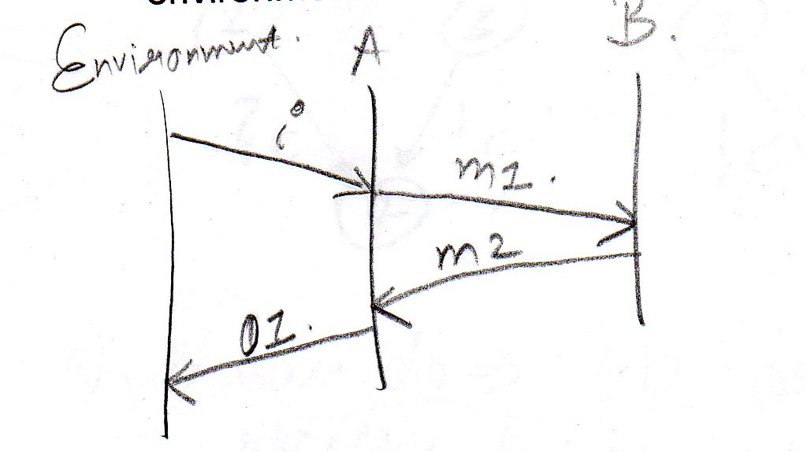Note: both machines have the same behavior. They both start in their initial state (state 1 of the diagram above)

Question (b): (3 points) The same, for the case that both machines receive an i input from their environment at the same time.

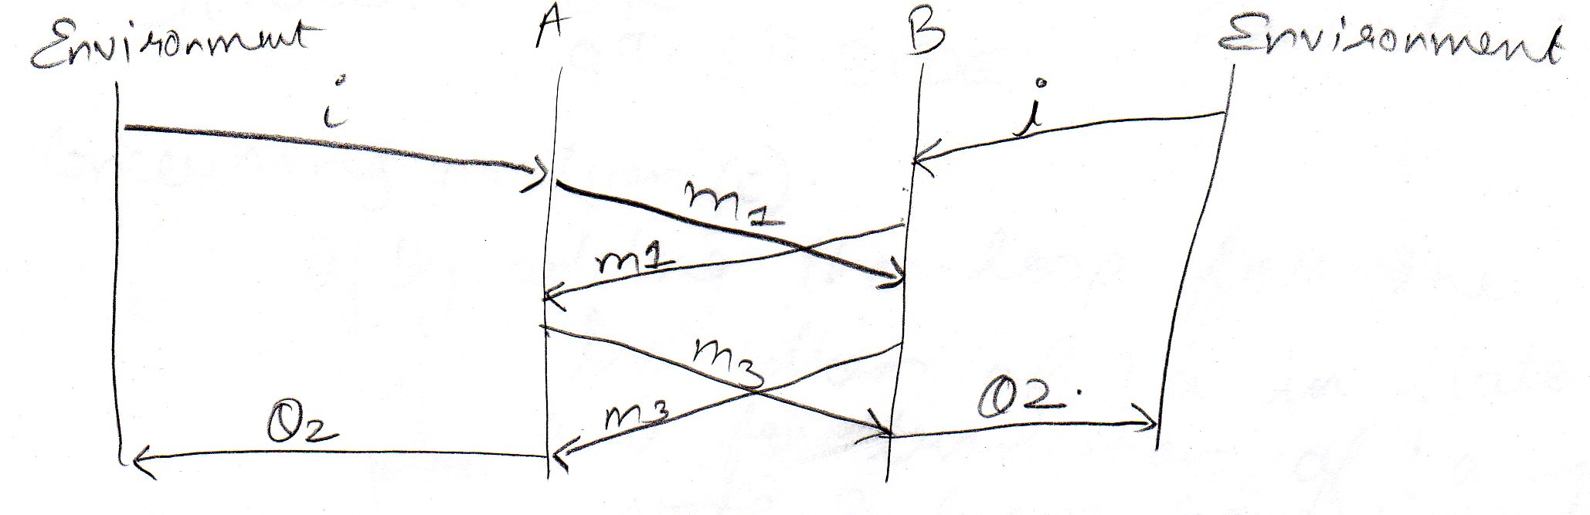
- [6 marks] This is about reachability analysis: We consider two state machines A and B with the behaviors shown in the diagrams below (to the left) and communicating by message passing with FIFO queuing.

When B sends a b message, the global system goes into the state ( b : 1 | - : 3 ) as shown in the diagram on the right (which represents a partial reachability analysis of the system).

Question (a): (2 points) What are the transitions that are possible from the global state ( b : 1 | - : 3 ) ? Machine A can do !a or ?b

Question (b): (2 points) What are the global states that are reached by these transitions ? – Please show your answer by continuing the reachability diagram on the right side. You may also add some comments.See diagram below.

Question (c): (2 points) Is there the possibility of a non-specified reception ? – (a) Please explain. - (b) If there is this possibility, please explain how the specification of the two machines could be modified to avoid this problem.

The reachability analysis below shows two possibilities for the reception of b when the machine A is in state 2 (indicated by *). These are non-specified receptions. The problem can be solved by adding a transition from state 2 which receives interaction b.

Note: Many students misunderstood the notion of non-specified reception. It means that a message arrives to be received by a state machine, but this machine is in a state where its behavior has nothing specified for the case of this reception (no receiving transition).

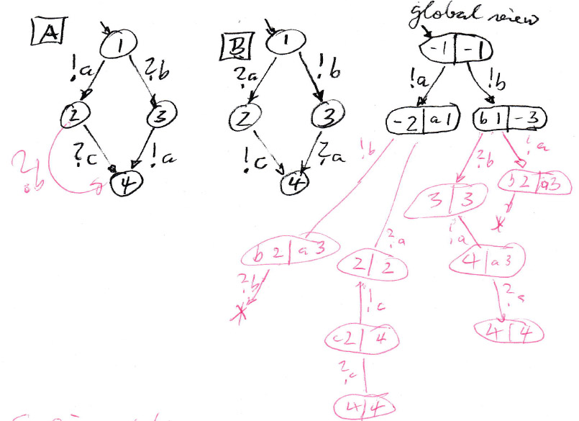

Problem Solving

- [15 marks] A new parking ticket dispenser works as follows: The user enters some 25 cent coins; after each coin the dispenser displays the amount of money entered and the length of the parking period corresponding to this amount – every 15 minutes costs 25 cents. Then the user may push a button to decrement the parking period by units of 15 minutes – or enter further coins. When the displayed parking period is acceptable to the user, the user pushes another button to request the printing of the parking ticket. The user will then receive the parking ticket and possibly the returned coins corresponding to the overpayment made. The user may then request the printing of a receipt (using yet another button). If this button is not pressed, the dispenser will go back to its initial state after 10 seconds. At any point before the parking ticket is printed, the user may cancel the transaction and any not used coins will be returned.

The controller of the parking ticket dispenser has a user interface and an interface with the other hardware units. This latter interface includes the following interactions:
- Input: coin – meaning that 25 cents have been entered.
- Outputs:
  - return – returns one 25 cent coin.
  - print (String s) – prints a ticket or invoice including the text s.

Question (a): Define the user interface of the dispenser machine and the interactions that occur at this interface.

The interactions with the hardware units above also represent interactions with the user, because the hardware units interaction with the user. In addition, there are the following user interactions:

Inputs to the controller: coin, decrement, ticket, requestReceipt, cancel

Output from the controller: display money and time

Note: The reason for defining this interface before defining the dynamic behavior is : The names of these interactions should be used as inputs and outputs in the machine behavior of Question (b). Ideally, the meaning of each interaction should be explained by a little sentence.

Question (b): Write down a model that defines the dynamic behavior of the controller of the dispenser machine using the notation of UML State machine diagrams.

See next page

Question (c): Explain what assumptions you have made about the dynamic behavior of the machine – aspects that are not specified in the description above.

Note: The idea of this question is to clarify the requirements (which are given by the text above). The purpose is not to explain how you have organized your model (under Question (b)) – such explanations should be part of the answer to Question (b).

Here are examples of additional assumptions about the requirements:
- We assume that there is always enough paper and ink for printing.
- If at any time, there is no input from the user during a period of 20 seconds, any entered coins will be returned.

Dynamic Behavior

Notes:
- The behavior should be as precise as possible.
- Before you build your state machine, you should have a good understanding of the interactions at the interface (Question(a)).
- Before you build your state machine, you should determine what kind of additional state variables you need in order to define the behavior precisely – e.g. counting repetitions of loops, determining output parameters, determining whether certain transitions are possible (they may depend on some input parameters and/or internal variables.

Explanation of the following model:
- I use two internal variables: coins (number of coins entered) and units (number of time units reserved for parking).
- In the idle state, the machine should display the money entered (coins * 25 in cents) and the reserved parking period (units * 15 in minutes) – this is not shown in the state machine below.
- The state machine model below returns a coin each time that the parking period is decremented. One could also define the behavior such that the unused portion of the entered money is returned when the ticket is printed. In this case, one should add the action “coins = coins – units;” and have an intermediate state similar to the one on the left (for returning unused coins) before accepting the requestReceipt input.
- Note: I forgot to add the action “coins = 0; units = 0;” to the last transition “after 10sec” - - and “units = 0; “ to the transition “[coins = 0]”.
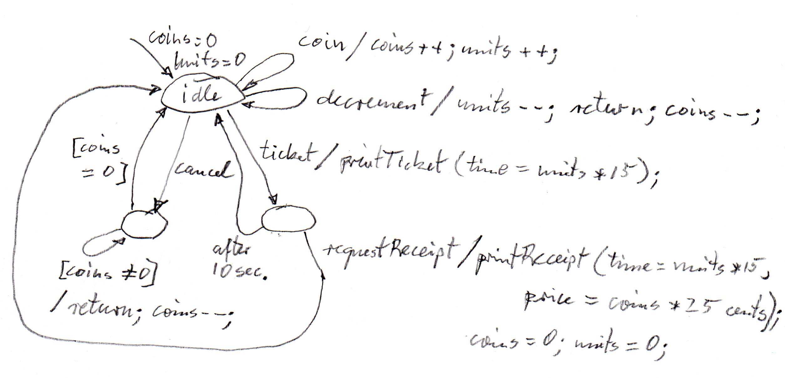
Annex A: Example of modeling an LTS using the LTSA tool

// Hotel V3 - modified

CLIENT = (checkIn -> enter -> eat -> chargeRoom -> checkOut -> CLIENT
| payCash -> CLIENT ).

RESTAURANT = (enter -> ORDER | checkIn -> RESTAURANT | checkOut -> RESTAURANT),
ORDER = (eat -> DONE),
DONE = (payCash -> RESTAURANT | chargeRoom -> RESTAURANT).

ROOM = (checkIn -> OCCUPIED),
OCCUPIED = (checkOut -> FREED | chargeRoom -> OCCUPIED),
FREED = (clean -> ROOM).

||SYSTEM = (CLIENT || RESTAURANT || ROOM).

property CHECK_A = (eat -> payCash -> CHECK_A).
||CHECKED_SYSTEM_A = (SYSTEM || CHECK_A).

Output of the LTSA tool when doing “Composition”
Composition:
CHECKED_SYSTEM_A = SYSTEM.CLIENT || SYSTEM.RESTAURANT || SYSTEM.ROOM || CHECK_A
State Space:
5 * 3 * 3 * 2 = 2 ** 8
Composing...
property CHECK_A violation.

Output of the LTSA tool when doing “CHECK” -- “Safety”
Trace to property violation in CHECK_A:
checkIn
enter
eat
chargeRoom
checkOut
clean
checkIn
enter
eat
Annex B: Algebraic Equivalence Properties of Regular Expressions

